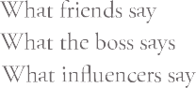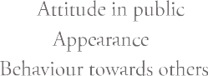

Spend too much time for job

searching

Want to learn about more vaccancies

**Empathy Map**

Many oppurtunities through online and offline

good experience

meet great knowledge peoples's

find more oppurtunities

Energy waste

lots of confusions to select a right job

feel too tired through travelling

need a good environment

I need a good job worth to my qualification

Many buildings different peoples

what is your idea about your future..?

What next..?

Lot's of online ads that dont't interest me

if you find a job or not..?

feel god about her/ his effort

I Think i made a good decision